Software Design
Software design is a mechanism to transform user requirements into some suitable form, which helps the programmer in software coding and implementation. It deals with representing the client's requirement, as described in SRS (Software Requirement Specification) document, into a form, i.e., easily implementable using programming language.
The software design phase is the first step in SDLC (Software Design Life Cycle), which moves the concentration from the problem domain to the solution domain. In software design, we consider the system to be a set of components or modules with clearly defined behaviors & boundaries.
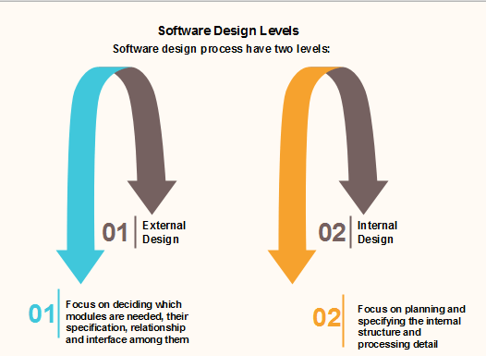

Objectives of Software Design
Following are the purposes of Software design:
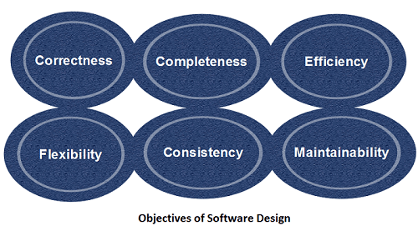
- Correctness:Software design should be correct as per requirement.
- Completeness:The design should have all components like data structures, modules, and external interfaces, etc.
- Efficiency:Resources should be used efficiently by the program.
- Flexibility:Able to modify on changing needs.
- Consistency:There should not be any inconsistency in the design.
- Maintainability: The design should be so simple so that it can be easily maintainable by other designers.

Software Design Principles
Software design principles are concerned with providing means to handle the complexity of the design process effectively. Effectively managing the complexity will not only reduce the effort needed for design but can also reduce the scope of introducing errors during design.

Following are the principles of Software Design
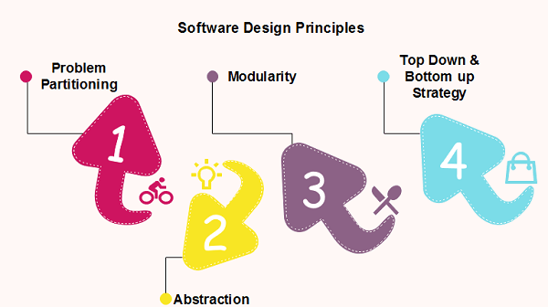

Problem Partitioning
For small problem, we can handle the entire problem at once but for the significant problem, divide the problems and conquer the problem it means to divide the problem into smaller pieces so that each piece can be captured separately.
For software design, the goal is to divide the problem into manageable pieces.

Benefits of Problem Partitioning
- Software is easy to understand
- Software becomes simple
- Software is easy to test
- Software is easy to modify
- Software is easy to maintain
- Software is easy to expand
These pieces cannot be entirely independent of each other as they together form the system. They have to cooperate and communicate to solve the problem. This communication adds complexity.

Note: As the number of partition increases = Cost of partition and complexity increases

Abstraction
An abstraction is a tool that enables a designer to consider a component at an abstract level without bothering about the internal details of the implementation. Abstraction can be used for existing element as well as the component being designed.
Here, there are two common abstraction mechanisms
- Functional Abstraction
- Data Abstraction

Functional Abstraction
- A module is specified by the method it performs.
- The details of the algorithm to accomplish the functions are not visible to the user of the function.
Functional abstraction forms the basis for Function oriented design approaches.

Data Abstraction
Details of the data elements are not visible to the users of data. Data Abstraction forms the basis for Object Oriented design approaches.

Modularity
Modularity specifies to the division of software into separate modules which are differently named and addressed and are integrated later on in to obtain the completely functional software. It is the only property that allows a program to be intellectually manageable. Single large programs are difficult to understand and read due to a large number of reference variables, control paths, global variables, etc.
The desirable properties of a modular system are:
- Each module is a well-defined system that can be used with other applications.
- Each module has single specified objectives.
- Modules can be separately compiled and saved in the library.
- Modules should be easier to use than to build.
- Modules are simpler from outside than inside.

Advantages and Disadvantages of Modularity
In this topic, we will discuss various advantage and disadvantage of Modularity.
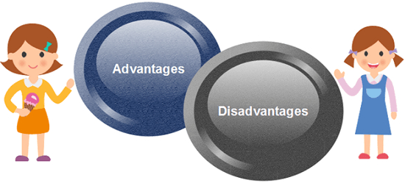
Advantages of Modularity
There are several advantages of Modularity
- It allows large programs to be written by several or different people
- It encourages the creation of commonly used routines to be placed in the library and used by other programs.
- It simplifies the overlay procedure of loading a large program into main storage.
- It provides more checkpoints to measure progress.
- It provides a framework for complete testing, more accessible to test
- It produced the well designed and more readable program.
Disadvantages of Modularity
There are several disadvantages of Modularity
- Execution time maybe, but not certainly, longer
- Storage size perhaps, but is not certainly, increased
- Compilation and loading time may be longer
- Inter-module communication problems may be increased
- More linkage required, run-time may be longer, more source lines must be written, and more documentation has to be done

Modular Design
Modular design reduces the design complexity and results in easier and faster implementation by allowing parallel development of various parts of a system. We discuss a different section of modular design in detail in this section:
1. Functional Independence: Functional independence is achieved by developing functions that perform only one kind of task and do not excessively interact with other modules. Independence is important because it makes implementation more accessible and faster. The independent modules are easier to maintain, test, and reduce error propagation and can be reused in other programs as well. Thus, functional independence is a good design feature which ensures software quality.
It is measured using two criteria:
- Cohesion: It measures the relative function strength of a module.
- Coupling: It measures the relative interdependence among modules.
2. Information hiding: The fundamental of Information hiding suggests that modules can be characterized by the design decisions that protect from the others, i.e., In other words, modules should be specified that data include within a module is inaccessible to other modules that do not need for such information.
The use of information hiding as design criteria for modular system provides the most significant benefits when modifications are required during testing's and later during software maintenance. This is because as most data and procedures are hidden from other parts of the software, inadvertent errors introduced during modifications are less likely to propagate to different locations within the software.

Strategy of Design
A good system design strategy is to organize the program modules in such a method that are easy to develop and latter too, change. Structured design methods help developers to deal with the size and complexity of programs. Analysts generate instructions for the developers about how code should be composed and how pieces of code should fit together to form a program.
To design a system, there are two possible approaches:
- Top-down Approach
- Bottom-up Approach
1. Top-down Approach: This approach starts with the identification of the main components and then decomposing them into their more detailed sub-components.
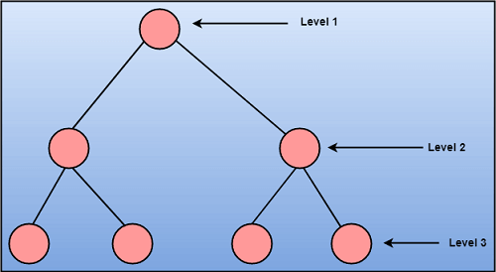
2. Bottom-up Approach: A bottom-up approach begins with the lower details and moves towards up the hierarchy, as shown in fig. This approach is suitable in case of an existing system.
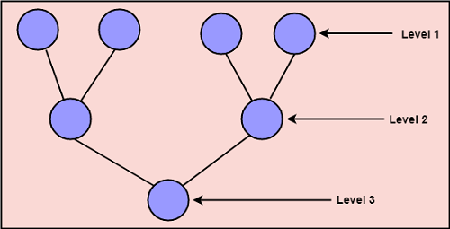

Coupling and Cohesion

Module Coupling
In software engineering, the coupling is the degree of interdependence between software modules. Two modules that are tightly coupled are strongly dependent on each other. However, two modules that are loosely coupled are not dependent on each other. Uncoupled modules have no interdependence at all within them.
The various types of coupling techniques are shown in fig:
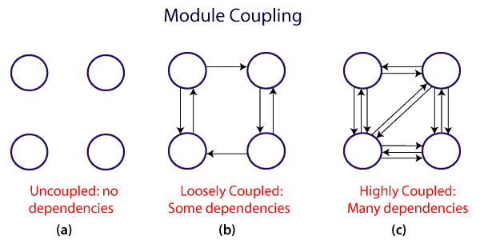
A good design is the one that has low coupling. Coupling is measured by the number of relations between the modules. That is, the coupling increases as the number of calls between modules increase or the amount of shared data is large. Thus, it can be said that a design with high coupling will have more errors.

Types of Module Coupling
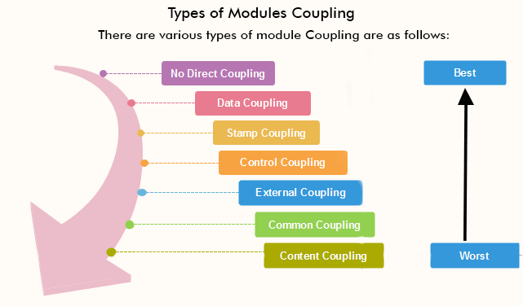
1. No Direct Coupling: There is no direct coupling between M1 and M2.
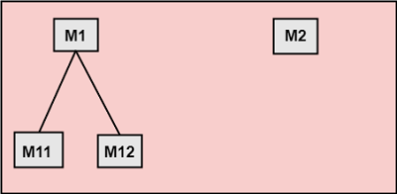
In this case, modules are subordinates to different modules. Therefore, no direct coupling.
2. Data Coupling: When data of one module is passed to another module, this is called data coupling.
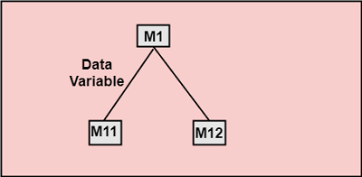
3. Stamp Coupling: Two modules are stamp coupled if they communicate using composite data items such as structure, objects, etc. When the module passes non-global data structure or entire structure to another module, they are said to be stamp coupled. For example, passing structure variable in C or object in C++ language to a module.
4. Control Coupling: Control Coupling exists among two modules if data from one module is used to direct the structure of instruction execution in another.
5. External Coupling: External Coupling arises when two modules share an externally imposed data format, communication protocols, or device interface. This is related to communication to external tools and devices.
6. Common Coupling: Two modules are common coupled if they share information through some global data items.
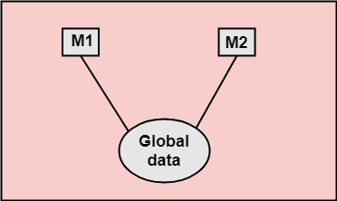
7. Content Coupling: Content Coupling exists among two modules if they share code, e.g., a branch from one module into another module.

Module Cohesion
In computer programming, cohesion defines to the degree to which the elements of a module belong together. Thus, cohesion measures the strength of relationships between pieces of functionality within a given module. For example, in highly cohesive systems, functionality is strongly related.
Cohesion is an ordinal type of measurement and is generally described as "high cohesion" or "low cohesion."
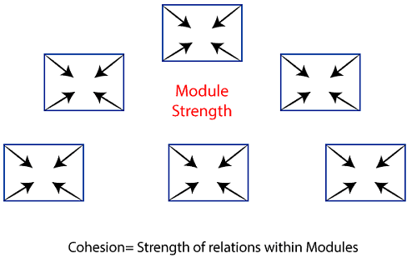

Types of Modules Cohesion
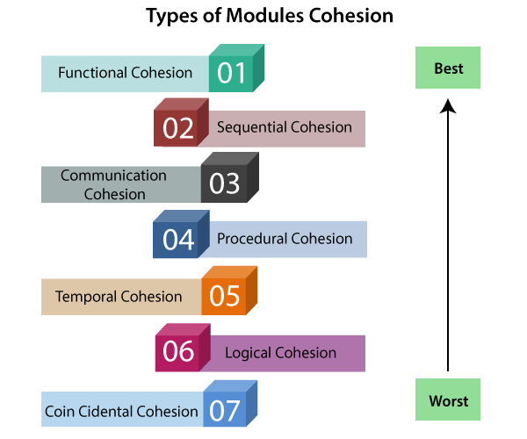
- Functional Cohesion: Functional Cohesion is said to exist if the different elements of a module, cooperate to achieve a single function.
- Sequential Cohesion: A module is said to possess sequential cohesion if the element of a module form the components of the sequence, where the output from one component of the sequence is input to the next.
- Communicational Cohesion: A module is said to have communicational cohesion, if all tasks of the module refer to or update the same data structure, e.g., the set of functions defined on an array or a stack.
- Procedural Cohesion: A module is said to be procedural cohesion if the set of purpose of the module are all parts of a procedure in which particular sequence of steps has to be carried out for achieving a goal, e.g., the algorithm for decoding a message.
- Temporal Cohesion: When a module includes functions that are associated by the fact that all the methods must be executed in the same time, the module is said to exhibit temporal cohesion.
- Logical Cohesion: A module is said to be logically cohesive if all the elements of the module perform a similar operation. For example Error handling, data input and data output, etc.
- Coincidental Cohesion: A module is said to have coincidental cohesion if it performs a set of tasks that are associated with each other very loosely, if at all.

Differentiate between Coupling and Cohesion
Coupling | Cohesion
Coupling is also called Inter-Module Binding. | Cohesion is also called Intra-Module Binding.
Coupling shows the relationships between modules. | Cohesion shows the relationship within the module.
Coupling shows the relative independence between the modules. | Cohesion shows the module's relative functional strength.
While creating, you should aim for low coupling, i.e., dependency among modules should be less. | While creating you should aim for high cohesion, i.e., a cohesive component/ module focuses on a single function (i.e., single-mindedness) with little interaction with other modules of the system.
In coupling, modules are linked to the other modules. | In cohesion, the module focuses on a single thing.

Function Oriented Design
Function Oriented design is a method to software design where the model is decomposed into a set of interacting units or modules where each unit or module has a clearly defined function. Thus, the system is designed from a functional viewpoint.

Design Notations
Design Notations are primarily meant to be used during the process of design and are used to represent design or design decisions. For a function-oriented design, the design can be represented graphically or mathematically by the following:
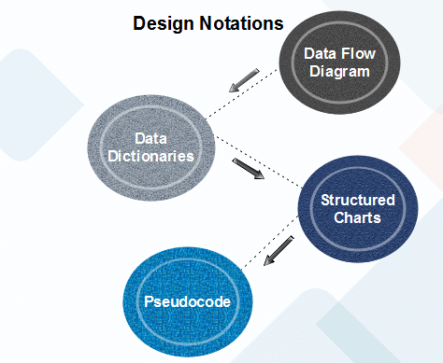

Data Flow Diagram
Data-flow design is concerned with designing a series of functional transformations that convert system inputs into the required outputs. The design is described as data-flow diagrams. These diagrams show how data flows through a system and how the output is derived from the input through a series of functional transformations.
Data-flow diagrams are a useful and intuitive way of describing a system. They are generally understandable without specialized training, notably if control information is excluded. They show end-to-end processing. That is the flow of processing from when data enters the system to where it leaves the system can be traced.
Data-flow design is an integral part of several design methods, and most CASE tools support data-flow diagram creation. Different ways may use different icons to represent data-flow diagram entities, but their meanings are similar.
The notation which is used is based on the following symbols:
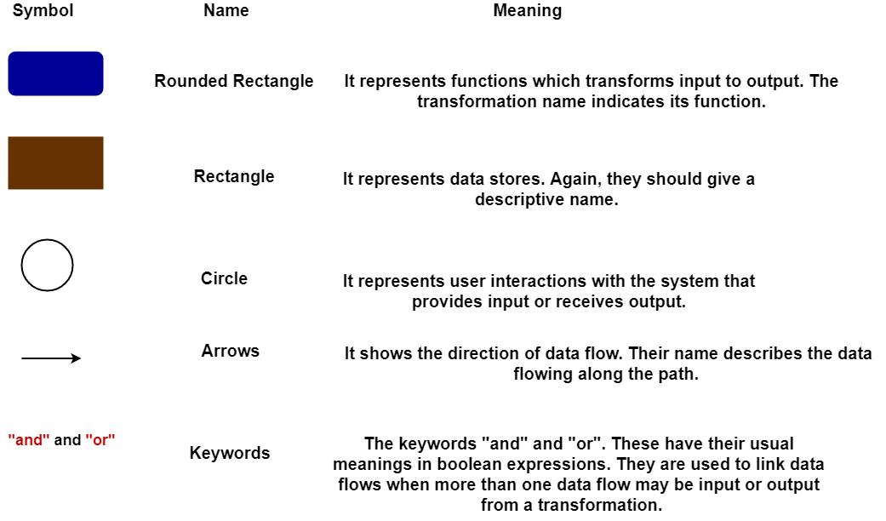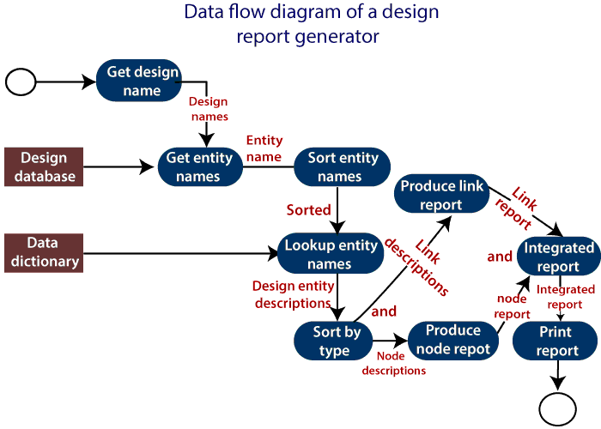
The report generator produces a report which describes all of the named entities in a data-flow diagram. The user inputs the name of the design represented by the diagram. The report generator then finds all the names used in the data-flow diagram. It looks up a data dictionary and retrieves information about each name. This is then collated into a report which is output by the system.

Data Dictionaries
A data dictionary lists all data elements appearing in the DFD model of a system. The data items listed contain all data flows and the contents of all data stores looking on the DFDs in the DFD model of a system.
A data dictionary lists the objective of all data items and the definition of all composite data elements in terms of their component data items. For example, a data dictionary entry may contain that the data grossPay consists of the parts regularPay and overtimePay.
grossPay = regularPay + overtimePay
For the smallest units of data elements, the data dictionary lists their name and their type.
A data dictionary plays a significant role in any software development process because of the following reasons:
- A Data dictionary provides a standard language for all relevant information for use by engineers working in a project. A consistent vocabulary for data items is essential since, in large projects, different engineers of the project tend to use different terms to refer to the same data, which unnecessarily causes confusion.
- The data dictionary provides the analyst with a means to determine the definition of various data structures in terms of their component elements.

Structured Charts
It partitions a system into block boxes. A Black box system that functionality is known to the user without the knowledge of internal design.
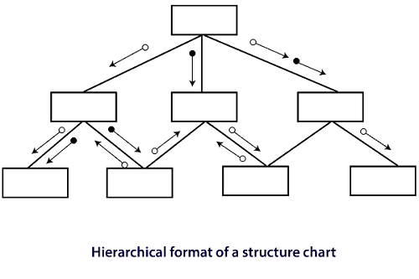
Structured Chart is a graphical representation which shows:
- System partitions into modules
- Hierarchy of component modules
- The relation between processing modules
- Interaction between modules
- Information passed between modules
The following notations are used in structured chart:
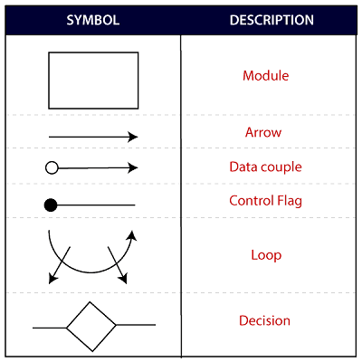

Pseudo-code
Pseudo-code notations can be used in both the preliminary and detailed design phases. Using pseudo-code, the designer describes system characteristics using short, concise, English Language phases that are structured by keywords such as If-Then-Else, While-Do, and End.

Object-Oriented Design
In the object-oriented design method, the system is viewed as a collection of objects (i.e., entities). The state is distributed among the objects, and each object handles its state data. For example, in a Library Automation Software, each library representative may be a separate object with its data and functions to operate on these data. The tasks defined for one purpose cannot refer or change data of other objects. Objects have their internal data which represent their state. Similar objects create a class. In other words, each object is a member of some class. Classes may inherit features from the superclass.
The different terms related to object design are:
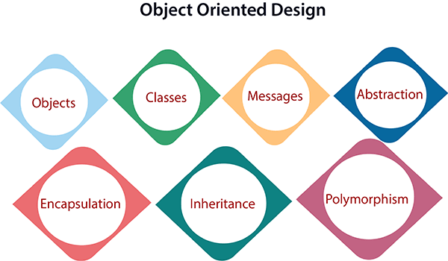
- Objects: All entities involved in the solution design are known as objects. For example, person, banks, company, and users are considered as objects. Every entity has some attributes associated with it and has some methods to perform on the attributes.
- Classes: A class is a generalized description of an object. An object is an instance of a class. A class defines all the attributes, which an object can have and methods, which represents the functionality of the object.
- Messages: Objects communicate by message passing. Messages consist of the integrity of the target object, the name of the requested operation, and any other action needed to perform the function. Messages are often implemented as procedure or function calls.
- Abstraction In object-oriented design, complexity is handled using abstraction. Abstraction is the removal of the irrelevant and the amplification of the essentials.
- Encapsulation: Encapsulation is also called an information hiding concept. The data and operations are linked to a single unit. Encapsulation not only bundles essential information of an object together but also restricts access to the data and methods from the outside world.
- Inheritance: OOD allows similar classes to stack up in a hierarchical manner where the lower or sub-classes can import, implement, and re-use allowed variables and functions from their immediate superclasses.This property of OOD is called an inheritance. This makes it easier to define a specific class and to create generalized classes from specific ones.
- Polymorphism: OOD languages provide a mechanism where methods performing similar tasks but vary in arguments, can be assigned the same name. This is known as polymorphism, which allows a single interface is performing functions for different types. Depending upon how the service is invoked, the respective portion of the code gets executed.

User Interface Design
The visual part of a computer application or operating system through which a client interacts with a computer or software. It determines how commands are given to the computer or the program and how data is displayed on the screen.

Types of User Interface
There are two main types of User Interface:
- Text-Based User Interface or Command Line Interface
- Graphical User Interface (GUI)
Text-Based User Interface: This method relies primarily on the keyboard. A typical example of this is UNIX.

Advantages
- Many and easier to customizations options.
- Typically capable of more important tasks.

Disadvantages
- Relies heavily on recall rather than recognition.
- Navigation is often more difficult.
Graphical User Interface (GUI): GUI relies much more heavily on the mouse. A typical example of this type of interface is any versions of the Windows operating systems.

GUI Characteristics
Characteristics | Descriptions
Windows | Multiple windows allow different information to be displayed simultaneously on the user's screen.
Icons | Icons different types of information. On some systems, icons represent files. On other icons describes processes.
Menus | Commands are selected from a menu rather than typed in a command language.
Pointing | A pointing device such as a mouse is used for selecting choices from a menu or indicating items of interests in a window.
Graphics | Graphics elements can be mixed with text or the same display.

Advantages
- Less expert knowledge is required to use it.
- Easier to Navigate and can look through folders quickly in a guess and check manner.
- The user may switch quickly from one task to another and can interact with several different applications.

Disadvantages
- Typically decreased options.
- Usually less customizable. Not easy to use one button for tons of different variations.

UI Design Principles
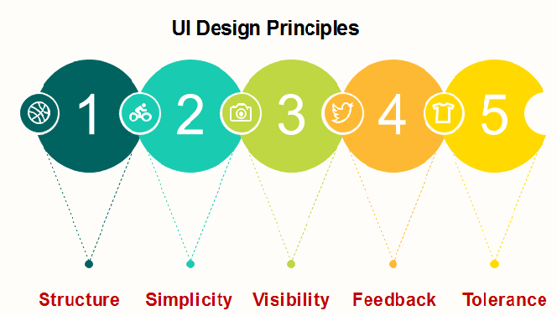
Structure: Design should organize the user interface purposefully, in the meaningful and usual based on precise, consistent models that are apparent and recognizable to users, putting related things together and separating unrelated things, differentiating dissimilar things and making similar things resemble one another. The structure principle is concerned with overall user interface architecture.
Simplicity: The design should make the simple, common task easy, communicating clearly and directly in the user's language, and providing good shortcuts that are meaningfully related to longer procedures.
Visibility: The design should make all required options and materials for a given function visible without distracting the user with extraneous or redundant data.
Feedback: The design should keep users informed of actions or interpretation, changes of state or condition, and bugs or exceptions that are relevant and of interest to the user through clear, concise, and unambiguous language familiar to users.
Tolerance: The design should be flexible and tolerant, decreasing the cost of errors and misuse by allowing undoing and redoing while also preventing bugs wherever possible by tolerating varied inputs and sequences and by interpreting all reasonable actions.

Coding
The coding is the process of transforming the design of a system into a computer language format. This coding phase of software development is concerned with software translating design specification into the source code. It is necessary to write source code & internal documentation so that conformance of the code to its specification can be easily verified.
Coding is done by the coder or programmers who are independent people than the designer. The goal is not to reduce the effort and cost of the coding phase, but to cut to the cost of a later stage. The cost of testing and maintenance can be significantly reduced with efficient coding.

Goals of Coding
- To translate the design of system into a computer language format: The coding is the process of transforming the design of a system into a computer language format, which can be executed by a computer and that perform tasks as specified by the design of operation during the design phase.
- To reduce the cost of later phases: The cost of testing and maintenance can be significantly reduced with efficient coding.
- Making the program more readable: Program should be easy to read and understand. It increases code understanding having readability and understandability as a clear objective of the coding activity can itself help in producing more maintainable software.
For implementing our design into code, we require a high-level functional language. A programming language should have the following characteristics:

Characteristics of Programming Language
Following are the characteristics of Programming Language:
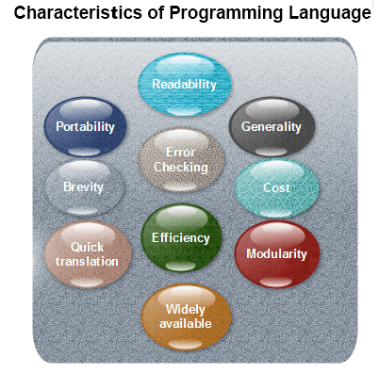
Readability: A good high-level language will allow programs to be written in some methods that resemble a quite-English description of the underlying functions. The coding may be done in an essentially self-documenting way.
Portability: High-level languages, being virtually machine-independent, should be easy to develop portable software.
Generality: Most high-level languages allow the writing of a vast collection of programs, thus relieving the programmer of the need to develop into an expert in many diverse languages.
Brevity: Language should have the ability to implement the algorithm with less amount of code. Programs mean in high-level languages are often significantly shorter than their low-level equivalents.
Error checking: A programmer is likely to make many errors in the development of a computer program. Many high-level languages invoke a lot of bugs checking both at compile-time and run-time.
Cost: The ultimate cost of a programming language is a task of many of its characteristics.
Quick translation: It should permit quick translation.
Efficiency: It should authorize the creation of an efficient object code.
Modularity: It is desirable that programs can be developed in the language as several separately compiled modules, with the appropriate structure for ensuring self-consistency among these modules.
Widely available: Language should be widely available, and it should be feasible to provide translators for all the major machines and all the primary operating systems.
A coding standard lists several rules to be followed during coding, such as the way variables are to be named, the way the code is to be laid out, error return conventions, etc.

Coding Standards
General coding standards refers to how the developer writes code, so here we will discuss some essential standards regardless of the programming language being used.
The following are some representative coding standards:
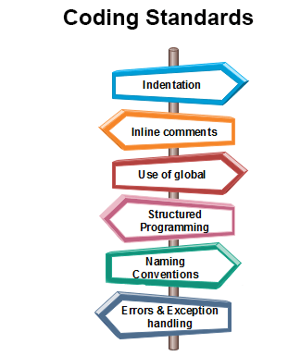
- Indentation: Proper and consistent indentation is essential in producing easy to read and maintainable programs.
Indentation should be used to:
  - Emphasize the body of a control structure such as a loop or a select statement.
  - Emphasize the body of a conditional statement
  - Emphasize a new scope block
- Inline comments: Inline comments analyze the functioning of the subroutine, or key aspects of the algorithm shall be frequently used.
- Rules for limiting the use of global: These rules file what types of data can be declared global and what cannot.
- Structured Programming: Structured (or Modular) Programming methods shall be used. "GOTO" statements shall not be used as they lead to "spaghetti" code, which is hard to read and maintain, except as outlined line in the FORTRAN Standards and Guidelines.
- Naming conventions for global variables, local variables, and constant identifiers: A possible naming convention can be that global variable names always begin with a capital letter, local variable names are made of small letters, and constant names are always capital letters.
- Error return conventions and exception handling system: Different functions in a program report the way error conditions are handled should be standard within an organization. For example, different tasks while encountering an error condition should either return a 0 or 1 consistently.

Coding Guidelines
General coding guidelines provide the programmer with a set of the best methods which can be used to make programs more comfortable to read and maintain. Most of the examples use the C language syntax, but the guidelines can be tested to all languages.
The following are some representative coding guidelines recommended by many software development organizations.
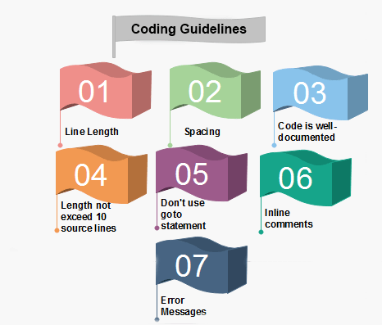
1. Line Length: It is considered a good practice to keep the length of source code lines at or below 80 characters. Lines longer than this may not be visible properly on some terminals and tools. Some printers will truncate lines longer than 80 columns.
2. Spacing: The appropriate use of spaces within a line of code can improve readability.
Example:
Bad: cost=price+(price*sales_tax)
fprintf(stdout ,"The total cost is %5.2f\n",cost);
Better: cost = price + ( price * sales_tax )
fprintf (stdout,"The total cost is %5.2f\n",cost);
3. The code should be well-documented: As a rule of thumb, there must be at least one comment line on the average for every three-source line.
4. The length of any function should not exceed 10 source lines: A very lengthy function is generally very difficult to understand as it possibly carries out many various functions. For the same reason, lengthy functions are possible to have a disproportionately larger number of bugs.
5. Do not use goto statements: Use of goto statements makes a program unstructured and very tough to understand.
6. Inline Comments: Inline comments promote readability.
7. Error Messages: Error handling is an essential aspect of computer programming. This does not only include adding the necessary logic to test for and handle errors but also involves making error messages meaningful.

Programming Style
Programming style refers to the technique used in writing the source code for a computer program. Most programming styles are designed to help programmers quickly read and understands the program as well as avoid making errors. (Older programming styles also focused on conserving screen space.) A good coding style can overcome the many deficiencies of a first programming language, while poor style can defeat the intent of an excellent language.
The goal of good programming style is to provide understandable, straightforward, elegant code. The programming style used in a various program may be derived from the coding standards or code conventions of a company or other computing organization, as well as the preferences of the actual programmer.
Some general rules or guidelines in respect of programming style:
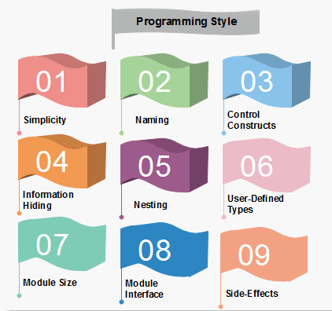
1. Clarity and simplicity of Expression: The programs should be designed in such a manner so that the objectives of the program is clear.
2. Naming: In a program, you are required to name the module, processes, and variable, and so on. Care should be taken that the naming style should not be cryptic and non-representative.
For Example: a = 3.14 * r * r
area of circle = 3.14 * radius * radius;
3. Control Constructs: It is desirable that as much as a possible single entry and single exit constructs used.
4. Information hiding: The information secure in the data structures should be hidden from the rest of the system where possible. Information hiding can decrease the coupling between modules and make the system more maintainable.
5. Nesting: Deep nesting of loops and conditions greatly harm the static and dynamic behavior of a program. It also becomes difficult to understand the program logic, so it is desirable to avoid deep nesting.
6. User-defined types: Make heavy use of user-defined data types like enum, class, structure, and union. These data types make your program code easy to write and easy to understand.
7. Module size: The module size should be uniform. The size of the module should not be too big or too small. If the module size is too large, it is not generally functionally cohesive. If the module size is too small, it leads to unnecessary overheads.
8. Module Interface: A module with a complex interface should be carefully examined.
9. Side-effects: When a module is invoked, it sometimes has a side effect of modifying the program state. Such side-effect should be avoided where as possible.

Structured Programming
In structured programming, we sub-divide the whole program into small modules so that the program becomes easy to understand. The purpose of structured programming is to linearize control flow through a computer program so that the execution sequence follows the sequence in which the code is written. The dynamic structure of the program than resemble the static structure of the program. This enhances the readability, testability, and modifiability of the program. This linear flow of control can be managed by restricting the set of allowed applications construct to a single entry, single exit formats.

Why we use Structured Programming?
We use structured programming because it allows the programmer to understand the program easily. If a program consists of thousands of instructions and an error occurs then it is complicated to find that error in the whole program, but in structured programming, we can easily detect the error and then go to that location and correct it. This saves a lot of time.
These are the following rules in structured programming:

Structured Rule One: Code Block
If the entry conditions are correct, but the exit conditions are wrong, the error must be in the block. This is not true if the execution is allowed to jump into a block. The error might be anywhere in the program. Debugging under these circumstances is much harder.
Rule 1 of Structured Programming: A code block is structured, as shown in the figure. In flow-charting condition, a box with a single entry point and single exit point are structured. Structured programming is a method of making it evident that the program is correct.
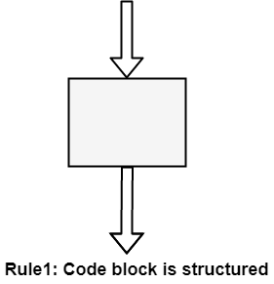

Structure Rule Two: Sequence
A sequence of blocks is correct if the exit conditions of each block match the entry conditions of the following block. Execution enters each block at the block's entry point and leaves through the block's exit point. The whole series can be regarded as a single block, with an entry point and an exit point.
Rule 2 of Structured Programming: Two or more code blocks in the sequence are structured, as shown in the figure.
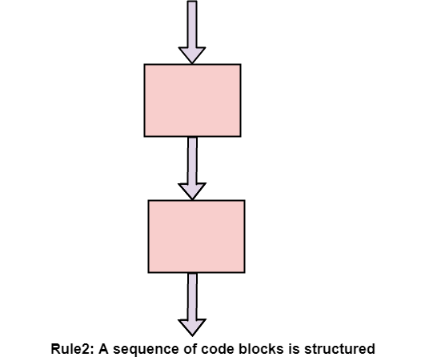

Structured Rule Three: Alternation
If-then-else is frequently called alternation (because there are alternative options). In structured programming, each choice is a code block. If alternation is organized as in the flowchart at right, then there is one entry point (at the top) and one exit point (at the bottom). The structure should be coded so that if the entry conditions are fulfilled, then the exit conditions are satisfied (just like a code block).
Rule 3 of Structured Programming: The alternation of two code blocks is structured, as shown in the figure.
An example of an entry condition for an alternation method is: register $8 includes a signed integer. The exit condition may be: register $8 includes the absolute value of the signed number. The branch structure is used to fulfill the exit condition.
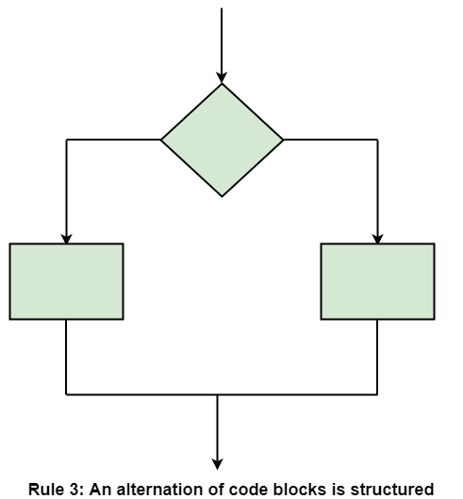

Structured Rule 4: Iteration
Iteration (while-loop) is organized as at right. It also has one entry point and one exit point. The entry point has conditions that must be satisfied, and the exit point has requirements that will be fulfilled. There are no jumps into the form from external points of the code.
Rule 4 of Structured Programming: The iteration of a code block is structured, as shown in the figure.
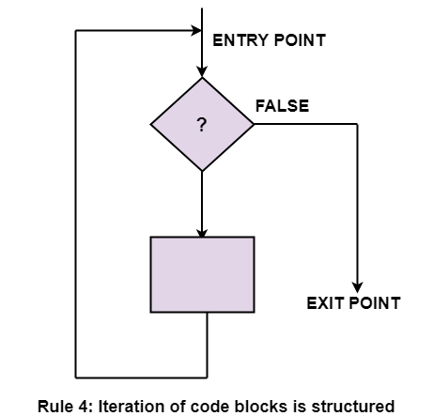

Structured Rule 5: Nested Structures
In flowcharting conditions, any code block can be spread into any of the structures. If there is a portion of the flowchart that has a single entry point and a single exit point, it can be summarized as a single code block.
Rule 5 of Structured Programming: A structure (of any size) that has a single entry point and a single exit point is equivalent to a code block. For example, we are designing a program to go through a list of signed integers calculating the absolute value of each one. We may (1) first regard the program as one block, then (2) sketch in the iteration required, and finally (3) put in the details of the loop body, as shown in the figure.
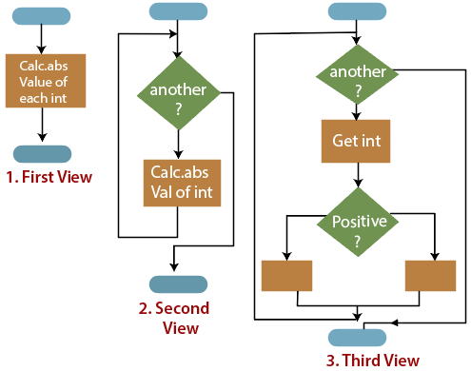
The other control structures are the case, do-until, do-while, and for are not needed. However, they are sometimes convenient and are usually regarded as part of structured programming. In assembly language, they add little convenience.

Software Reliability
Software Reliability means Operational reliability. It is described as the ability of a system or component to perform its required functions under static conditions for a specific period.
Software reliability is also defined as the probability that a software system fulfills its assigned task in a given environment for a predefined number of input cases, assuming that the hardware and the input are free of error.
Software Reliability is an essential connect of software quality, composed with functionality, usability, performance, serviceability, capability, installability, maintainability, and documentation. Software Reliability is hard to achieve because the complexity of software turn to be high. While any system with a high degree of complexity, containing software, will be hard to reach a certain level of reliability, system developers tend to push complexity into the software layer, with the speedy growth of system size and ease of doing so by upgrading the software.
For example, large next-generation aircraft will have over 1 million source lines of software on-board; next-generation air traffic control systems will contain between one and two million lines; the upcoming International Space Station will have over two million lines on-board and over 10 million lines of ground support software; several significant life-critical defense systems will have over 5 million source lines of software. While the complexity of software is inversely associated with software reliability, it is directly related to other vital factors in software quality, especially functionality, capability, etc.

Software Failure Mechanisms
The software failure can be classified as:
Transient failure: These failures only occur with specific inputs.
Permanent failure: This failure appears on all inputs.
Recoverable failure: System can recover without operator help.
Unrecoverable failure: System can recover with operator help only.
Non-corruption failure: Failure does not corrupt system state or data.
Corrupting failure: It damages the system state or data.
Software failures may be due to bugs, ambiguities, oversights or misinterpretation of the specification that the software is supposed to satisfy, carelessness or incompetence in writing code, inadequate testing, incorrect or unexpected usage of the software or other unforeseen problems.

Hardware vs. Software Reliability
Hardware Reliability | Software Reliability
Hardware faults are mostly physical faults. | Software faults are design faults, which are tough to visualize, classify, detect, and correct.
Hardware components generally fail due to wear and tear. | Software component fails due to bugs.
In hardware, design faults may also exist, but physical faults generally dominate. | In software, we can simply find a strict corresponding counterpart for "manufacturing" as the hardware manufacturing process, if the simple action of uploading software modules into place does not count. Therefore, the quality of the software will not change once it is uploaded into the storage and start running
Hardware exhibits the failure features shown in the following figure:  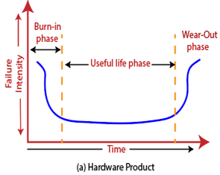  It is called the bathtub curve. Period A, B, and C stand for burn-in phase, useful life phase, and end-of-life phase respectively. | Software reliability does not show the same features similar as hardware. A possible curve is shown in the following figure:  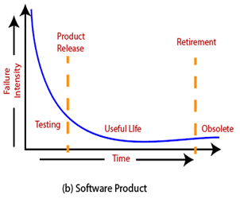  If we projected software reliability on the same axes.
There are two significant differences between hardware and software curves are:
One difference is that in the last stage, the software does not have an increasing failure rate as hardware does. In this phase, the software is approaching obsolescence; there are no motivations for any upgrades or changes to the software. Therefore, the failure rate will not change.
The second difference is that in the useful-life phase, the software will experience a radical increase in failure rate each time an upgrade is made. The failure rate levels off gradually, partly because of the defects create and fixed after the updates.
The upgrades in above figure signify feature upgrades, not upgrades for reliability. For feature upgrades, the complexity of software is possible to be increased, since the functionality of the software is enhanced. Even error fixes may be a reason for more software failures if the bug fix induces other defects into the software. For reliability upgrades, it is likely to incur a drop in software failure rate, if the objective of the upgrade is enhancing software reliability, such as a redesign or reimplementation of some modules using better engineering approaches, such as clean-room method.
A partial list of the distinct features of software compared to hardware is listed below:
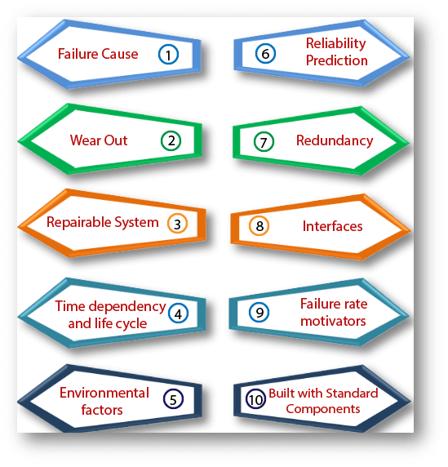
Failure cause: Software defects are primarily designed defects.
Wear-out: Software does not have an energy-related wear-out phase. Bugs can arise without warning.
Repairable system: Periodic restarts can help fix software queries.
Time dependency and life cycle: Software reliability is not a purpose of operational time.
Environmental factors: Do not affect Software reliability, except it may affect program inputs.
Reliability prediction: Software reliability cannot be predicted from any physical basis since it depends entirely on human factors in design.
Redundancy: It cannot improve Software reliability if identical software elements are used.
Interfaces: Software interfaces are merely conceptual other than visual.
Failure rate motivators: It is generally not predictable from analyses of separate statements.
Built with standard components: Well-understood and extensively tested standard element will help improve maintainability and reliability. But in the software industry, we have not observed this trend. Code reuse has been around for some time but to a minimal extent. There are no standard elements for software, except for some standardized logic structures.

Software Reliability Measurement Techniques
Reliability metrics are used to quantitatively expressed the reliability of the software product. The option of which parameter is to be used depends upon the type of system to which it applies & the requirements of the application domain.
Measuring software reliability is a severe problem because we don't have a good understanding of the nature of software. It is difficult to find a suitable method to measure software reliability and most of the aspects connected to software reliability. Even the software estimates have no uniform definition. If we cannot measure the reliability directly, something can be measured that reflects the features related to reliability.
The current methods of software reliability measurement can be divided into four categories:
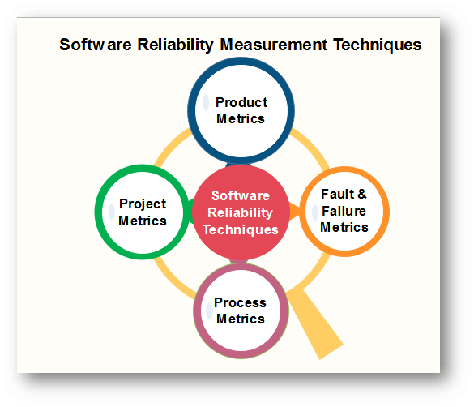

1. Product Metrics
Product metrics are those which are used to build the artifacts, i.e., requirement specification documents, system design documents, etc. These metrics help in the assessment if the product is right sufficient through records on attributes like usability, reliability, maintainability & portability. In these measurements are taken from the actual body of the source code.
- Software size is thought to be reflective of complexity, development effort, and reliability. Lines of Code (LOC), or LOC in thousands (KLOC), is an initial intuitive approach to measuring software size. The basis of LOC is that program length can be used as a predictor of program characteristics such as effort &ease of maintenance. It is a measure of the functional complexity of the program and is independent of the programming language.
- Function point metric is a technique to measure the functionality of proposed software development based on the count of inputs, outputs, master files, inquires, and interfaces.
- Test coverage metric size fault and reliability by performing tests on software products, assuming that software reliability is a function of the portion of software that is successfully verified or tested.
- Complexity is directly linked to software reliability, so representing complexity is essential. Complexity-oriented metrics is a way of determining the complexity of a program's control structure by simplifying the code into a graphical representation. The representative metric is McCabe's Complexity Metric.
- Quality metrics measure the quality at various steps of software product development. An vital quality metric is Defect Removal Efficiency (DRE). DRE provides a measure of quality because of different quality assurance and control activities applied throughout the development process.

2. Project Management Metrics
Project metrics define project characteristics and execution. If there is proper management of the project by the programmer, then this helps us to achieve better products. A relationship exists between the development process and the ability to complete projects on time and within the desired quality objectives. Cost increase when developers use inadequate methods. Higher reliability can be achieved by using a better development process, risk management process, configuration management process.
These metrics are:
- Number of software developers
- Staffing pattern over the life-cycle of the software
- Cost and schedule
- Productivity

3. Process Metrics
Process metrics quantify useful attributes of the software development process & its environment. They tell if the process is functioning optimally as they report on characteristics like cycle time & rework time. The goal of process metric is to do the right job on the first time through the process. The quality of the product is a direct function of the process. So process metrics can be used to estimate, monitor, and improve the reliability and quality of software. Process metrics describe the effectiveness and quality of the processes that produce the software product.
Examples are:
- The effort required in the process
- Time to produce the product
- Effectiveness of defect removal during development
- Number of defects found during testing
- Maturity of the process

4. Fault and Failure Metrics
A fault is a defect in a program which appears when the programmer makes an error and causes failure when executed under particular conditions. These metrics are used to determine the failure-free execution software.
To achieve this objective, a number of faults found during testing and the failures or other problems which are reported by the user after delivery are collected, summarized, and analyzed. Failure metrics are based upon customer information regarding faults found after release of the software. The failure data collected is therefore used to calculate failure density, Mean Time between Failures (MTBF), or other parameters to measure or predict software reliability.

Reliability Metrics
Reliability metrics are used to quantitatively expressed the reliability of the software product. The option of which metric is to be used depends upon the type of system to which it applies & the requirements of the application domain.
Some reliability metrics which can be used to quantify the reliability of the software product are as follows:
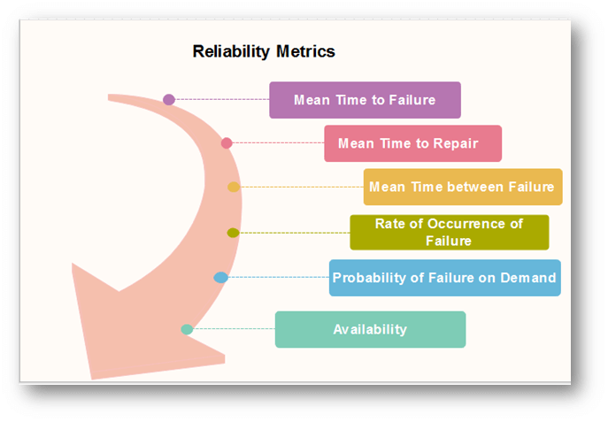

1. Mean Time to Failure (MTTF)
MTTF is described as the time interval between the two successive failures. An MTTF of 200 mean that one failure can be expected each 200-time units. The time units are entirely dependent on the system & it can even be stated in the number of transactions. MTTF is consistent for systems with large transactions.
For example, It is suitable for computer-aided design systems where a designer will work on a design for several hours as well as for Word-processor systems.
To measure MTTF, we can evidence the failure data for n failures. Let the failures appear at the time instants t₁,t₂.....t_{n}.
MTTF can be calculated as
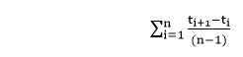

2. Mean Time to Repair (MTTR)
Once failure occurs, some-time is required to fix the error. MTTR measures the average time it takes to track the errors causing the failure and to fix them.

3. Mean Time Between Failure (MTBR)
We can merge MTTF & MTTR metrics to get the MTBF metric.
MTBF = MTTF + MTTR
Thus, an MTBF of 300 denoted that once the failure appears, the next failure is expected to appear only after 300 hours. In this method, the time measurements are real-time & not the execution time as in MTTF.

4. Rate of occurrence of failure (ROCOF)
It is the number of failures appearing in a unit time interval. The number of unexpected events over a specific time of operation. ROCOF is the frequency of occurrence with which unexpected role is likely to appear. A ROCOF of 0.02 mean that two failures are likely to occur in each 100 operational time unit steps. It is also called the failure intensity metric.

5. Probability of Failure on Demand (POFOD)
POFOD is described as the probability that the system will fail when a service is requested. It is the number of system deficiency given several systems inputs.
POFOD is the possibility that the system will fail when a service request is made.
A POFOD of 0.1 means that one out of ten service requests may fail.POFOD is an essential measure for safety-critical systems. POFOD is relevant for protection systems where services are demanded occasionally.

6. Availability (AVAIL)
Availability is the probability that the system is applicable for use at a given time. It takes into account the repair time & the restart time for the system. An availability of 0.995 means that in every 1000 time units, the system is feasible to be available for 995 of these. The percentage of time that a system is applicable for use, taking into account planned and unplanned downtime. If a system is down an average of four hours out of 100 hours of operation, its AVAIL is 96%.

Software Metrics for Reliability
The Metrics are used to improve the reliability of the system by identifying the areas of requirements.

Different Types of Software Metrics are:-
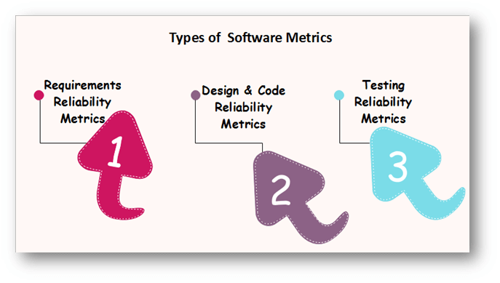

Requirements Reliability Metrics
Requirements denote what features the software must include. It specifies the functionality that must be contained in the software. The requirements must be written such that is no misconception between the developer & the client. The requirements must include valid structure to avoid the loss of valuable data.
The requirements should be thorough and in a detailed manner so that it is simple for the design stage. The requirements should not include inadequate data. Requirement Reliability metrics calculates the above-said quality factors of the required document.

Design and Code Reliability Metrics
The quality methods that exists in design and coding plan are complexity, size, and modularity. Complex modules are tough to understand & there is a high probability of occurring bugs. The reliability will reduce if modules have a combination of high complexity and large size or high complexity and small size. These metrics are also available to object-oriented code, but in this, additional metrics are required to evaluate the quality.

Testing Reliability Metrics
These metrics use two methods to calculate reliability.
First, it provides that the system is equipped with the tasks that are specified in the requirements. Because of this, the bugs due to the lack of functionality reduces.
The second method is calculating the code, finding the bugs & fixing them. To ensure that the system includes the functionality specified, test plans are written that include multiple test cases. Each test method is based on one system state and tests some tasks that are based on an associated set of requirements. The goals of an effective verification program is to ensure that each elements is tested, the implication being that if the system passes the test, the requirement?s functionality is contained in the delivered system.

Software Fault Tolerance
Software fault tolerance is the ability for software to detect and recover from a fault that is happening or has already happened in either the software or hardware in the system in which the software is running to provide service by the specification.
Software fault tolerance is a necessary component to construct the next generation of highly available and reliable computing systems from embedded systems to data warehouse systems.
To adequately understand software fault tolerance it is important to understand the nature of the problem that software fault tolerance is supposed to solve.
Software faults are all design faults. Software manufacturing, the reproduction of software, is considered to be perfect. The source of the problem being solely designed faults is very different than almost any other system in which fault tolerance is the desired property.

Software Fault Tolerance Techniques
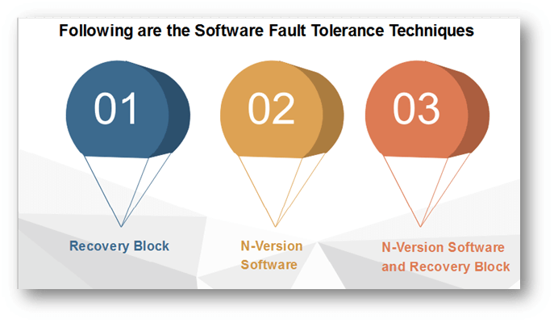

1. Recovery Block
The recovery block method is a simple technique developed by Randel. The recovery block operates with an adjudicator, which confirms the results of various implementations of the same algorithm. In a system with recovery blocks, the system view is broken down into fault recoverable blocks.
The entire system is constructed of these fault-tolerant blocks. Each block contains at least a primary, secondary, and exceptional case code along with an adjudicator. The adjudicator is the component, which determines the correctness of the various blocks to try.
The adjudicator should be kept somewhat simple to maintain execution speed and aide in correctness. Upon first entering a unit, the adjudicator first executes the primary alternate. (There may be N alternates in a unit which the adjudicator may try.) If the adjudicator determines that the fundamental block failed, it then tries to roll back the state of the system and tries the secondary alternate.
If the adjudicator does not accept the results of any of the alternates, it then invokes the exception handler, which then indicates the fact that the software could not perform the requested operation.
The recovery block technique increases the pressure on the specification to be specific enough to create various multiple alternatives that are functionally the same. This problem is further discussed in the context of the N-version software method.

2. N-Version Software
The N-version software methods attempt to parallel the traditional hardware fault tolerance concept of N-way redundant hardware. In an N-version software system, every module is done with up to N different methods. Each variant accomplishes the same function, but hopefully in a various way. Each version then submits its answer to voter or decider, which decides the correct answer, and returns that as the result of the module.
This system can hopefully overcome the design faults present in most software by relying upon the design diversity concept. An essential distinction in N-version software is the fact that the system could include multiple types of hardware using numerous versions of the software.
N-version software can only be successful and successfully tolerate faults if the required design diversity is met. The dependence on appropriate specifications in N-version software, (and recovery blocks,) cannot be stressed enough.

3. N-Version Software and Recovery Blocks
The differences between the recovery block technique and the N-version technique are not too numerous, but they are essential. In traditional recovery blocks, each alternative would be executed serially until an acceptable solution is found as determined by the adjudicator. The recovery block method has been extended to contain concurrent execution of the various alternatives.
The N-version techniques have always been designed to be implemented using N-way hardware concurrently. In a serial retry system, the cost in time of trying multiple methods may be too expensive, especially for a real-time system. Conversely, concurrent systems need the expense of N-way hardware and a communications network to connect them.
The recovery block technique requires that each module build a specific adjudicator; in the N-version method, a single decider may be used. The recovery block technique, assuming that the programmer can create a sufficiently simple adjudicator, will create a system, which is challenging to enter into an incorrect state.

Software Reliability Models
A software reliability model indicates the form of a random process that defines the behavior of software failures to time.
Software reliability models have appeared as people try to understand the features of how and why software fails, and attempt to quantify software reliability.
Over 200 models have been established since the early 1970s, but how to quantify software reliability remains mostly unsolved.
There is no individual model that can be used in all situations. No model is complete or even representative.
Most software models contain the following parts:
- Assumptions
- Factors
A mathematical function that includes the reliability with the elements. The mathematical function is generally higher-order exponential or logarithmic.

Software Reliability Modeling Techniques
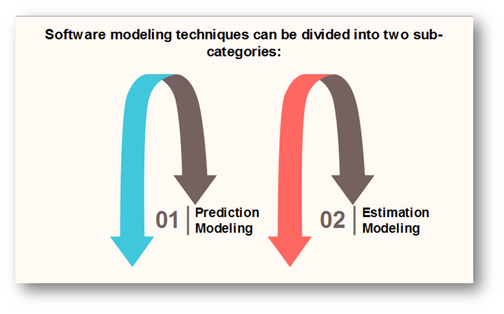
Both kinds of modeling methods are based on observing and accumulating failure data and analyzing with statistical inference.

Differentiate between software reliability prediction models and software reliability estimation models
Basics | Prediction Models | Estimation Models
Data Reference | Uses historical information | Uses data from the current software development effort.
When used in development cycle | Usually made before development or test phases; can be used as early as concept phase. | Usually made later in the life cycle (after some data have been collected); not typically used in concept or development phases.
Time Frame | Predict reliability at some future time. | Estimate reliability at either present or some next time.

Reliability Models
A reliability growth model is a numerical model of software reliability, which predicts how software reliability should improve over time as errors are discovered and repaired. These models help the manager in deciding how much efforts should be devoted to testing. The objective of the project manager is to test and debug the system until the required level of reliability is reached.
Following are the Software Reliability Models are:
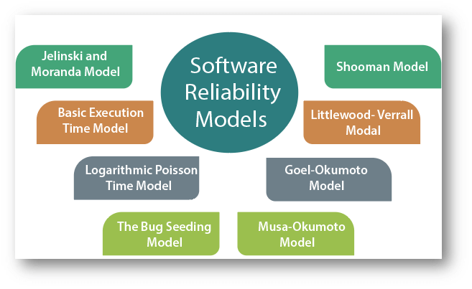

Software Engineering-Mapping Requirements in Software Architecture

Software requirements can be mapped into various representations of the design model. The architectural styles represent radically different architectures, so it should come as no surprise that a comprehensive mapping that accomplishes the transition from the requirements model to a variety of architectural styles does not exist. In fact, there is no practical mapping for some architectural styles, and the designer must approach the translation of requirements to design for these styles in an ad hoc fashion.

To illustrate one approach to architectural mapping, we consider the call and return architecture—an extremely common structure for many types of systems. The mapping technique to be presented enables a designer to derive reasonably complex call and return architectures from data flow diagrams within the requirements model. The technique, sometimes called structured design, has its origins in earlier design concepts that stressed modularity , top-down design , and structured programming . Stevens, Myers, and Constantine were early proponents of software design based on the flow of data through a system. Early work was refined and presented in books by Myers and Yourdon and Constantine.

Structured design is often characterized as a data flow-oriented design method because it provides a convenient transition from a data flow diagram to software architecture. The transition from information flow (represented as a DFD) to program structure is accomplished as part of a six-step process: (1) the type of information flow is established; (2) flow boundaries are indicated; (3) the DFD is mapped into program structure; (4) control hierarchy is defined; (5) resultant structure is refined using design measures and heuristics; and (6) the architectural description is refined and elaborated.
The type of information flow is the driver for the mapping approach required in step 3. In the following sections we examine two flow types.
Transform Flow

Recalling the fundamental system model (level 0 data flow diagram), information must enter and exit software in an "external world" form. For example, data typed on a keyboard, tones on a telephone line, and video images in a multimedia application are all forms of external world information. Such externalized data must be converted into an internal form for processing. Information enters the system along paths that transform external data into an internal form. These paths are identified as incoming flow. At the kernel of the software, a transition occurs. Incoming data are passed through a transform center and begin to move along paths that now lead "out" of the software. Data moving along these paths are called outgoing flow. The overall flow of data occurs in a sequential manner and follows one, or only a few, "straight line" paths. When a segment of a data flow diagram exhibits these characteristics, transform flow is present.

Transaction Flow
The fundamental system model implies transform flow; therefore, it is possible to characterize all data flow in this category. However, information flow is often characterized by a single data item, called a transaction, that triggers other data flow along one of many paths. When a DFD takes the form shown in figure, transaction flow is present.

Transaction flow is characterized by data moving along an incoming path that converts xternal world information into a transaction. The transaction is evaluated and, based on its value, flow along one of many action paths is initiated. The hub of information flow from which many action paths emanate is called a transaction center.
It should be noted that, within a DFD for a large system, both transform and transaction flow may be present. For example, in a transaction-oriented flow, information flow along an action path may have transform flow characteristics.

Software Engineering-Transform Mapping
Transform mapping is a set of design steps that allows a DFD with transform flow characteristics to be mapped into a specific architectural style. In this section transform mapping is described by applying design steps to an example system—a portion of the SafeHome security software.
An Example
The SafeHome security system is representative of many computer-based products and systems in use today. The product monitors the real world and reacts to changes that it encounters. It also interacts with a user through a series of typed inputs and alphanumeric displays. The level 0 data flow diagram for SafeHome, is shown in figure

During requirements analysis, more detailed flow models would be created for SafeHome. In addition, control and process specifications, a data dictionary, and various behavioral models would also be created.
Design Steps
The preceding example will be used to illustrate each step in transform mapping. The steps begin with a re-evaluation of work done during requirements analysis and then move to the design of the software architecture.
Step 1. Review the fundamental system model. The fundamental system model encompasses the level 0 DFD and supporting information. In actuality, the design step begins with an evaluation of both the System Specification and the Software Requirements Specification. Both documents describe information flow and structure at the software interface. Figure 1 and 2 depict level 0 and level 1 data flow for the SafeHome software.

Step 2. Review and refine data flow diagrams for the software. Information obtained from analysis models contained in the Software Requirements Specification is refined to produce greater detail. For example, the level 2 DFD for monitor sensors is examined, and a level 3 data flow diagram is derived . At level 3, each transform in the data flow diagram exhibits relatively high cohesion. That is, the process implied by a transform performs a single, distinct function that can be implemented as a module9 in the SafeHome software. Therefore, the DFD in figure contains sufficient detail for a "first cut" at the design of architecture for the monitor sensors subsystem, and we proceed without further refinement.

Step 3. Determine whether the DFD has transform or transaction flow characteristics. In general, information flow within a system can always be represented as transform. However, when an obvious transaction characteristic is encountered, a different design mapping is recommended. In this step, the designer selects global (softwarewide) flow characteristics based on the prevailing nature of the DFD. In addition, local regions of transform or transaction flow are isolated. These subflows can be used to refine program architecture derived from a global characteristic described previously. For now, we focus our attention only on the monitor sensors subsystem data flow depicted in figure.

Evaluating the DFD , we see data entering the software along one incoming path and exiting along three outgoing paths. No distinct transaction center is implied (although the transform establishes alarm conditions that could be perceived as such). Therefore, an overall transform characteristic will be assumed for information flow.

Step 4. Isolate the transform center by specifying incoming and outgoing flow boundaries. In the preceding section incoming flow was described as a path in which information is converted from external to internal form; outgoing flow converts from internal to external form. Incoming and outgoing flow boundaries are open to interpretation. That is, different designers may select slightly different points in the flow as boundary locations. In fact, alternative design solutions can be derived by varying the placement of flow boundaries. Although care should be taken when boundaries are selected, a variance of one bubble along a flow path will generally have little impact on the final program structure.

Flow boundaries for the example are illustrated as shaded curves running vertically through the flow in the above figure. The transforms (bubbles) that constitute the transform center lie within the two shaded boundaries that run from top to bottom in the figure. An argument can be made to readjust a boundary (e.g, an incoming flow boundary separating read sensors and acquire response info could be proposed). The emphasis in this design step should be on selecting reasonable boundaries, rather than lengthy iteration on placement of divisions.

Step 5. Perform "first-level factoring." Program structure represents a top-down distribution of control. Factoring results in a program structure in which top-level modules perform decision making and low-level modules perform most input, computation, and output work. Middle-level modules perform some control and do moderate amounts of work.
When transform flow is encountered, a DFD is mapped to a specific structure (a call and return architecture) that provides control for incoming, transform, and outgoing information processing. This first-level factoring for the monitor sensors subsystem is illustrated in figure below. A main controller (called monitor sensors executive) resides at the top of the program structure and coordinates the following subordinate control functions:
• An incoming information processing controller, called sensor input controller, coordinates receipt of all incoming data.
• A transform flow controller, called alarm conditions controller, supervises all operations on data in internalized form (e.g., a module that invokes various data transformation procedures).
• An outgoing information processing controller, called alarm output controller,
coordinates production of output information.

Although a three-pronged structure is implied by figure complex flows in large systems may dictate two or more control modules for each of the generic control functions described previously. The number of modules at the first level should be limited to the minimum that can accomplish control functions and still maintain good coupling and cohesion characteristics.
Step 6. Perform "second-level factoring." Second-level factoring is accomplished by mapping individual transforms (bubbles) of a DFD into appropriate modules within the architecture. Beginning at the transform center boundary and moving outward along incoming and then outgoing paths, transforms are mapped into subordinate levels of the software structure. The general approach to second-level factoring for the SafeHome data flow is illustrated in figure.

Although the figure illustrates a one-to-one mapping between DFD transforms and software modules, different mappings frequently occur. Two or even three bubbles can be combined and represented as one module (recalling potential problems with cohesion) or a single bubble may be expanded to two or more modules. Practical considerations and measures of design quality dictate the outcome of secondlevel factoring. Review and refinement may lead to changes in this structure, but it can serve as a "first-iteration" design.
Second-level factoring for incoming flow follows in the same manner. Factoring is again accomplished by moving outward from the transform center boundary on the incoming flow side. The transform center of monitor sensors subsystem software is mapped somewhat differently. Each of the data conversion or calculation transforms of the transform portion of the DFD is mapped into a module subordinate to the transform controller. A completed first-iteration architecture is shown in figure.

The modules mapped in the preceding manner and shown in figure represent an initial design of software architecture. Although modules are named in a manner that implies function, a brief processing narrative (adapted from the PSPEC created during analysis modeling) should be written for each. The narrative describes
• Information that passes into and out of the module (an interface description).
• Information that is retained by a module, such as data stored in a local data structure.
• A procedural narrative that indicates major decision points and tasks.
• A brief discussion of restrictions and special features (e.g., file I/O, hardwaredependent characteristics, special timing requirements).
The narrative serves as a first-generation Design Specification. However, further refinement and additions occur regularly during this period of design.
Step 7. Refine the first-iteration architecture using design heuristics for improved software quality. A first-iteration architecture can always be refined by applying concepts of module independence . Modules are exploded or imploded to produce sensible factoring, good cohesion, minimal coupling, and most important, a structure that can be implemented without difficulty, tested without confusion, and maintained without grief.
Refinements are dictated by the analysis and assessment methods described briefly , as well as practical considerations and common sense. There are times, for example, when the controller for incoming data flow is totally unnecessary, when some input processing is required in a module that is subordinate to the transform controller, when high coupling due to global data cannot be avoided, or when
optimal structural characteristics cannot be achieved. Software requirements coupled with human judgment is the final arbiter. Many modifications can be made to the first iteration architecture developed for the SafeHome monitor sensors subsystem. Among many possibilities,
1. The incoming controller can be removed because it is unnecessary when a single incoming flow path is to be managed.
2. The substructure generated from the transform flow can be imploded into the module establish alarm conditions (which will now include the processing implied by select phone number). The transform controller will not be needed and the small decrease in cohesion is tolerable.
3. The modules format display and generate display can be imploded (we assume that display formatting is quite simple) into a new module called produce display.
The refined software structure for the monitor sensors subsystem is shown in figure.

The objective of the preceding seven steps is to develop an architectural representation of software. That is, once structure is defined, we can evaluate and refine software architecture by viewing it as a whole. Modifications made at this time require little additional work, yet can have a profound impact on software quality.
The reader should pause for a moment and consider the difference between the design approach described and the process of "writing programs." If code is the only representation of software, the developer will have great difficulty evaluating or refining at a global or holistic level and will, in fact, have difficulty "seeing the forest for the trees."

Software Engineering-Transaction Mapping
In many software applications, a single data item triggers one or a number of information flows that effect a function implied by the triggering data item. The data item, called a transaction, and its corresponding flow characteristics . In this section we consider design steps used to treat transaction flow.
An Example
Transaction mapping will be illustrated by considering the user interaction subsystem of the SafeHome software.

As shown in the figure, user commands flows into the system and results in additional information flow along one of three action paths. A single data item, command type, causes the data flow to fan outward from a hub. Therefore, the overall data flow characteristic is transaction oriented.
It should be noted that information flow along two of the three action paths accommodate additional incoming flow (e.g., system parameters and data are input on the "configure" action path). Each action path flows into a single transform, display messages and status.

Design Steps
The design steps for transaction mapping are similar and in some cases identical to steps for transform mapping . A major difference lies in the mapping of DFD to software structure.

Step 1. Review the fundamental system model.
Step 2. Review and refine data flow diagrams for the software.
Step 3. Determine whether the DFD has transform or transaction flow characteristics. Steps 1, 2, and 3 are identical to corresponding steps in transform mapping. The DFD shown in above figure has a classic transaction flow characteristic. However, flow along two of the action paths emanating from the invoke command processing bubble appears to have transform flow characteristics. Therefore, flow boundaries must be established for both flow types.
Step 4. Identify the transaction center and the flow characteristics along each of the action paths. The location of the transaction center can be immediately discerned from the DFD. The transaction center lies at the origin of a number of actions paths that flow radially from it. For the flow shown in figure , the invoke command processing bubble is the transaction center.

The incoming path (i.e., the flow path along which a transaction is received) and all action paths must also be isolated. Boundaries that define a reception path and action paths are also shown in the figure. Each action path must be evaluated for its individual flow characteristic. For example, the "password" path has transform characteristics. Incoming, transform, and outgoing flow are indicated with boundaries.
Step 5. Map the DFD in a program structure amenable to transaction processing. Transaction flow is mapped into an architecture that contains an incoming branch and a dispatch branch. The structure of the incoming branch is developed in much the same way as transform mapping. Starting at the transaction center, bubbles along the incoming path are mapped into modules. The structure of the dispatch branch contains a dispatcher module that controls all subordinate action modules. Each action flow path of the DFD is mapped to a structure that corresponds to its specific flow characteristics. This process is illustrated schematically infigure below.

Considering the user interaction subsystem data flow, first-level factoring for step 5 is shown in below figure.

The bubbles read user command and activate/deactivate system map directly into the architecture without the need for intermediate control modules. The transaction center, invoke command processing, maps directly into a dispatcher module of the same name. Controllers for system configuration and password processing are created as illustrated in figure.
Step 6. Factor and refine the transaction structure and the structure of each action path. Each action path of the data flow diagram has its own information flow characteristics. We have already noted that transform or transaction flow may be encountered. The action path-related "substructure" is developed using the design steps discussed in this and the preceding section.
As an example, consider the password processing information flow shown (inside shaded area) in figure The flow exhibits classic transform characteristics. A password is input (incoming flow) and transmitted to a transform center where it is compared against stored passwords. An alarm and warning message (outgoing flow) are produced (if a match is not obtained). The "configure" path is drawn similarly using the transform mapping. The resultant software architecture is shown in the figure below

.

Step 7. Refine the first-iteration architecture using design heuristics for improved software quality. This step for transaction mapping is identical to the corresponding step for transform mapping. In both design approaches, criteria such as module independence, practicality (efficacy of implementation and test), and maintainability must be carefully considered as structural modifications are proposed.
Design Steps
The Design steps for transaction mapping are same and in some cases identical to steps for transform mapping. The major dissimilarity lies in the mapping of the Data Flow Design to software structure.
Step 1: Reviewing the fundamental system model.
Step 2: Refine and Review data flow diagrams for the software.
Step 3: Determine whether the Data Flow Diagram has transaction or transform flow characteristics. By Steps 1, 2 and 3 are identical to corresponding steps in transform mapping. The Data Flow Design described in figure has a classic transaction flow characteristic. Moreover, flow behind 2 of the action paths emanating from the invoke command processing bubble appears to have transform flow characteristics. Thus, flow boundaries must be developed for both flow category.
Step 4: Identify the transaction center and the flow characteristics along each of the action paths. The location of the transaction center can be immediately discerned from the Data Flow Design. Transaction center lies at the origin of a number of actions paths that flow radically from it. For the flow shown in figure the invoke command processing bubble is the transaction center.
The incoming path example for the flow path behind that a transaction is received and all action paths must also be isolated. The Boundaries which describe an action path and reception paths are also described in the figure. Each and every action path must be evaluated for is individual flow characteristic. Example for, the password path shown enclosed through a shaded area in figure has transform characteristics. Transform, Incoming and outgoing flow are indicated with boundaries.

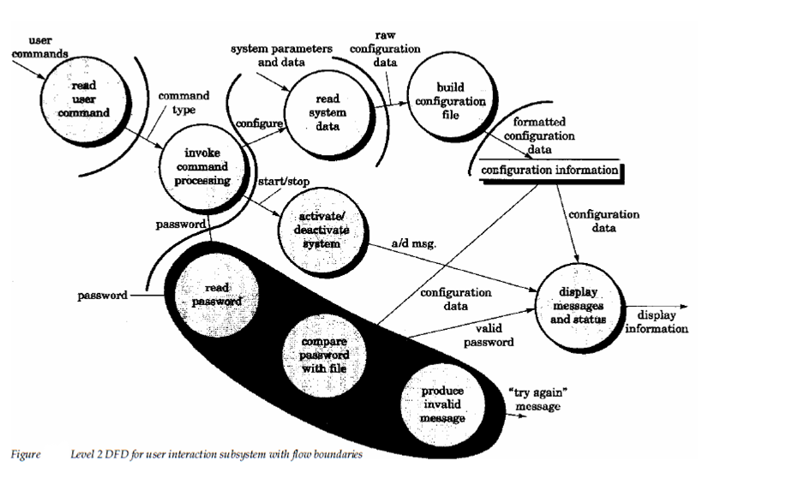

Step 5: Map the Data Flow Diagram in a program structure amenable to transaction processing. The Transaction flow is mapped into a program structure that contains an incoming branch and a dispatch branch. The Structure for the incoming branch is established in much the similar way as transform mapping. Begins at the transaction center, bubbles behind the incoming path are mapped into modules. Structure of the dispatch branch contains a dispatcher module which controls all subordinate action modules. Each and every action flow path of the Data Flow Diagram is mapped to a structure which corresponds to its exact flow characteristics. This procedure is described in figure 20.12.
By considering the user interaction subsystem data flow 1st level factoring for step 5 is describe in figure 20.13. The bubbles read user command and activate or deactivate system map directly into the program structure without the requirement for intermediate control modules. The invoke command processing, transaction center, maps directly into a dispatcher module of the similar name.Controllers for system password and configuration processing are mapped as demonstrate in figure 20.12.
Step 6: Factor and refine the transaction structure and the structure of each action path. Each and every action path of the data flow diagram has its own information flow characteristics. We have already noted which transform or transaction flow may be encountered. The action path-related substructure is established using the design steps discussed in this and the preceding section.
As an example let’s consider the password processing information flow described inside shaded field. The flow exhibits classic transform characteristics.The password is input transmitted and incoming flow to a transform center where it is compared against stored passwords.A warning and alarm message outgoing flow are produce if a match is not obtained. The configure path is drawn same using the transform mapping. The resultant program structure is described in figure

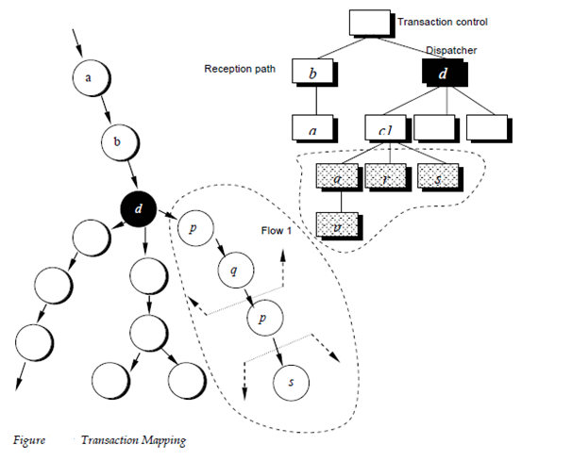

Step 7: Refine the first iteration program structure using design heuristics for improved software quality. The 7th step for transaction mapping is identical to the corresponding step for transform mapping. In the both design approaches and criteria such as module practicality, efficacy, independence of implementation and test and maintainability must be carefully considered as structural modifications are proposed.

